**Authenticating**

Authenticating users can be done in many ways. You need to decide – are you just authenticating username or username and password. We can use a text file to store them or an array, a 2D array or dictionary. Here are some examples:

**Dictionary**

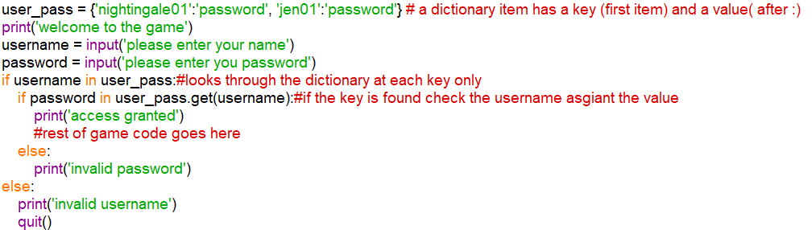

**Text file**

